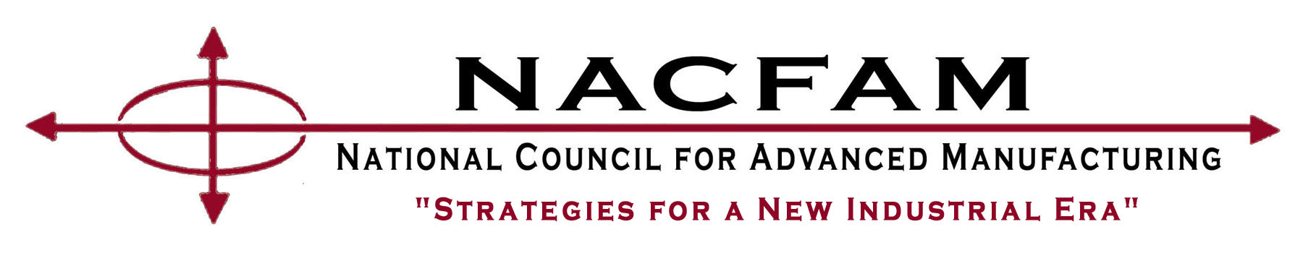
NACFAM’s Annual Conference
Hyatt Regency Crystal City Hotel – Arlington, VA

September 7-8, 2017

Conference Registration Form

Name:

Title:

Organization:

Address:

City, State, Zip: Phone:

Email address:

Conference Registration Fee (please check one only):

 | Rate for single registrant | Group rate (2 or more)
NACFAM Member | € $595 | € $525/person
Alliance Member | € $695 | € $625/person
Non-Member | € $875 | € $805/person

Note: To reserve a room at the Hyatt Regency Crystal City Hotel, use the dedicated website at https://aws.passkey.com/go/NACFAM2017 or call 1-888-421-1442 ... and indicate that you are with the National Council for Advanced Manufacturing Annual Conference so you can obtain the $169 guaranteed rate for NACFAM Conference attendees.

Registration Payment may be made by CHECK or by CREDIT CARD

If paying by CHECK , make payable to NACFAM and mail it and your completed conference registration form (this page) to Fred Wentzel, NACFAM, 2025 M St., NW, Suite 800, Washington, DC 20036.

If paying by CREDIT CARD, mail your credit card information and completed conference registration form (this page) to Fred Wentzel, NACFAM, 2025 M St., NW, Suite 800, Washington, DC 20036.

Check card you are using: ( ) Visa ( ) Master Card ( ) American Express

Credit Card # ( ) Exp. Date:

Number of people attending: Amount to be paid:

Signature:

